Mazer

Sean McDonald and Bruce Martin

PA11

Contents

User Manual

Running

Goal

Controller

Keyboard

Report

Dependencies

What we would do different

User Manual

Running

Use “make && ./Tutorial” In the build folder to build and run.

Goal

The Goal is to run into the chest. The chest has a collider and will reset the character/camera to the beginning upon reaching the chest.

Pic of Chest

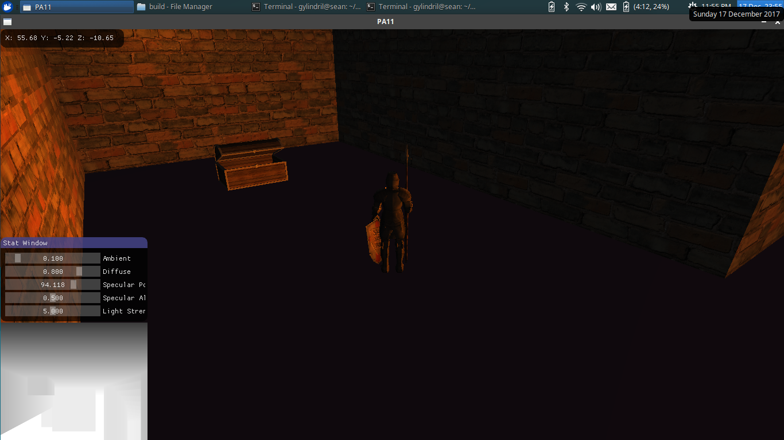

Controller

Left Analog Stick – Move Character

Right Analog Stick – Rotate Camera (Locked to XZ plane)

A - Jump

Keyboard

WASD – Move Character in standard fashion

Q – Rotate Camera CCW

E – Rotate Camera CW

Space - Jump

Esc - Quit

Bottom Left Image on screen is depth texture of GL_TEXTURE_CUBE_MAP_NEGATIVE_Z direction of the shadowcubemap of the first point light that you encounter. As you can tell, the shadowmapping does not work properly, and we have been debugging. The Neagitve Z direction is the last face drawn to, thus that’s the displayed face.

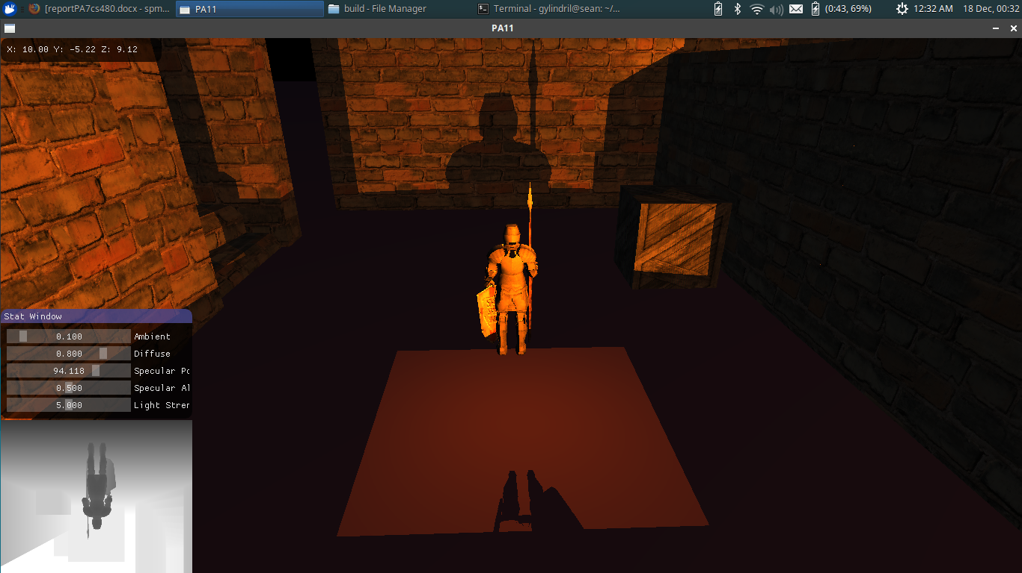

Notes: The Kinematic Character Controller currently steps the character up, even when not on the ground. It makes it easier to jump up obstacles, but is unintended.

Dependencies

Requiring Installation

GLEW

GLM

SDL2

ASSIMP

Bullet

Requiring No Installation

IMGUI (GUI)

STBI (Image Loading)

JSON for Modern C++ (For JSON config file handling)

Project Uses Makefile

Report

Issues: Had various with shadowmapping. Still was not able to complete the shadowmapping for point light/s and was debugging. Hence the texture in the lower left.

Next Time: Write generalized code from the beginning. Wasted a lot of time modifying/re-writing code as a result of this.